Product Overview
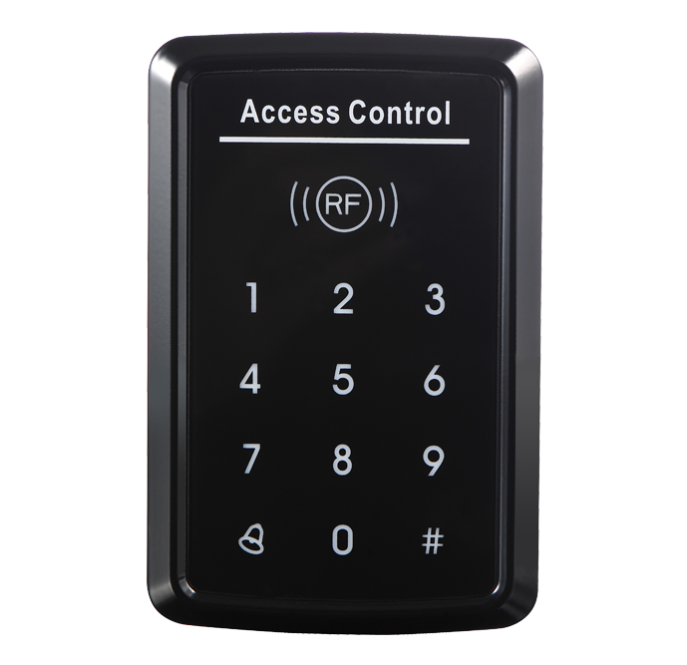
SA33-E

Single Door RFID Based Access Control
SA33-E is an Access Control Standalone Device with contact-less smart card and password verifications, which enables 3 verification modes (Card only, PIN only, and Card & PIN), and Tamper Alarm and Safety Mode to ensure maximum safety and flexibility. With Touch keypad with UV polished shell, 1 Relay output (optional) and 1 PUSH (low) output,1 door button Port and 1 doorbell Port, SA32 is simple but effective to use, its convenience and adaptability allows it to be well deployed in residential housing, offices and any other public facilities.
- Specifications:
1.1Technical parameters:
NO | Item | Value
1 | Operating voltage | DC 12V±10%
2 | Operating current | < 100mA
3 | Dimensions | 120mm×78mm×22mm
4 | Weight | 110g
5 | Ambient temperature | 0 —60
6 | Relative humidity | 20%—80%
7 | Storage | 1000users
8 | Card type (alternative)  Card reading distance | EM(ID) card(IC card for options)
9 |  | 1－15CM
  - Factory Default:
Programming  Password | 123456 | Common Access  Password | None
Backlight | Auto (for options) | Relay Unlock output | 5 Seconds
W26 port | Input (for options) | Security mode | OFF
Open mode | Card or Access Password  Access Password include Private Access Password (PIN) and  Common Access Password

  - Light and Sound indicates: Light : red and green
Light Description | Access control status
Red light flash every 1 sec （Slow flash） | Holding state
Red light is always ON | Programming state
Green light is always ON within Open time | Unlocking state
Green light flash every 0.5sec (Fast flash) | Pending further action
Sound : buzz
Description | I ndicates
1 short buzz | Valid input
3 short buzz | Invalid input
1 long buzz | Program success
Continuous long buzz | Restoring factory programming passwords

- Installations Guide
JP1 terminal:
NO | Mark | Color | Function
1 | +12 V | Red | Power+
₂ | _{GND} | Black | Power-
3 | PUSH | BLUE | Low level output
4 | OPEN | Yellow | Door Release
5 | BELL | Grey | BELL
6 | BELL | White | BELL
JP2 terminal:
NO | Mark | Color | Function | Remark
1 | +12V | Red | Power+ | For options
2 | GND | Black | Power-
3 | DATA0 | Green | WG DATA0
4 | DATA1 | White | WG DATA1
5 | NC | Brown | Relay NC output
6 | COM | Blue | Relay Com output
7 | NO | Purple | Relay NO output
Wiring diagram:

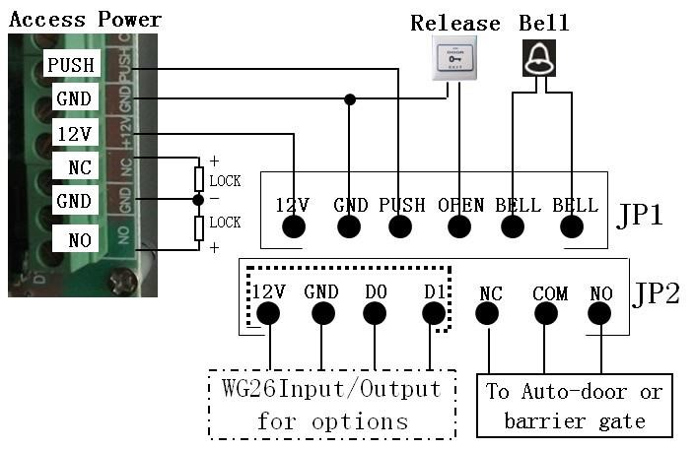

R
emark:
If
let relay drive electric-

“-” poles.
lock, please connect a reverse diode with the lock’s “+” and
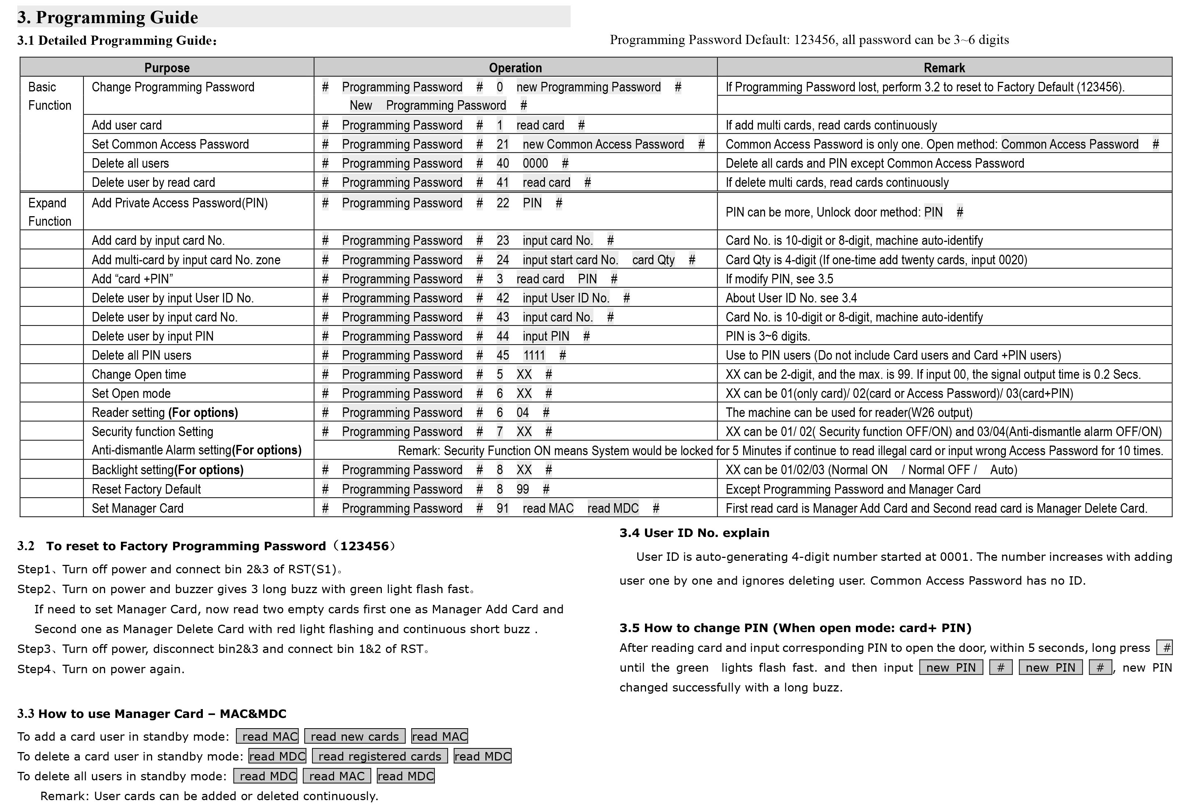3. Programming Guide
3.2
To reset to
Factory Progra mming Password (123456)
Step1
、
Turn off power and connect bin 2&3 of RST(S1)
。

Step2
、
Turn on power and buzzer gives 3 long buzz with green light flash fast
。

If need to set Manager Card, now read two empty cards first one as Manager Add Card and
Second one as Manager Delete Card with red light flashing and continuous short buzz .
Step3
、
Turn off power, disconnect bin2&3 and connect bin 1&2 of RST
。

Step4、Turn on power again.

3.3 How to use Manager Card - M AC & MDC
To add a card user in standby mode: read MAC read new cards read MAC
To delete a card user in standby mode: read MDC read registered cards read MDC
To delete all users in standby mode: read MDC read MAC read MDC Remark: User cards can be added or deleted continuously.

3.4 User ID No. explain
User ID is auto-generating 4-digit number started at 0001. The number increases with adding user one by one and ignores deleting user. Common Access Password has no ID.

3.5 How to change PIN (When open mode: card+ PIN)
#
After reading card and input corresponding PIN to open the door, within 5 seconds, long press until the green lights flash fast. and then input new PIN # new PIN # , new PIN changed successfully with a long buzz.

